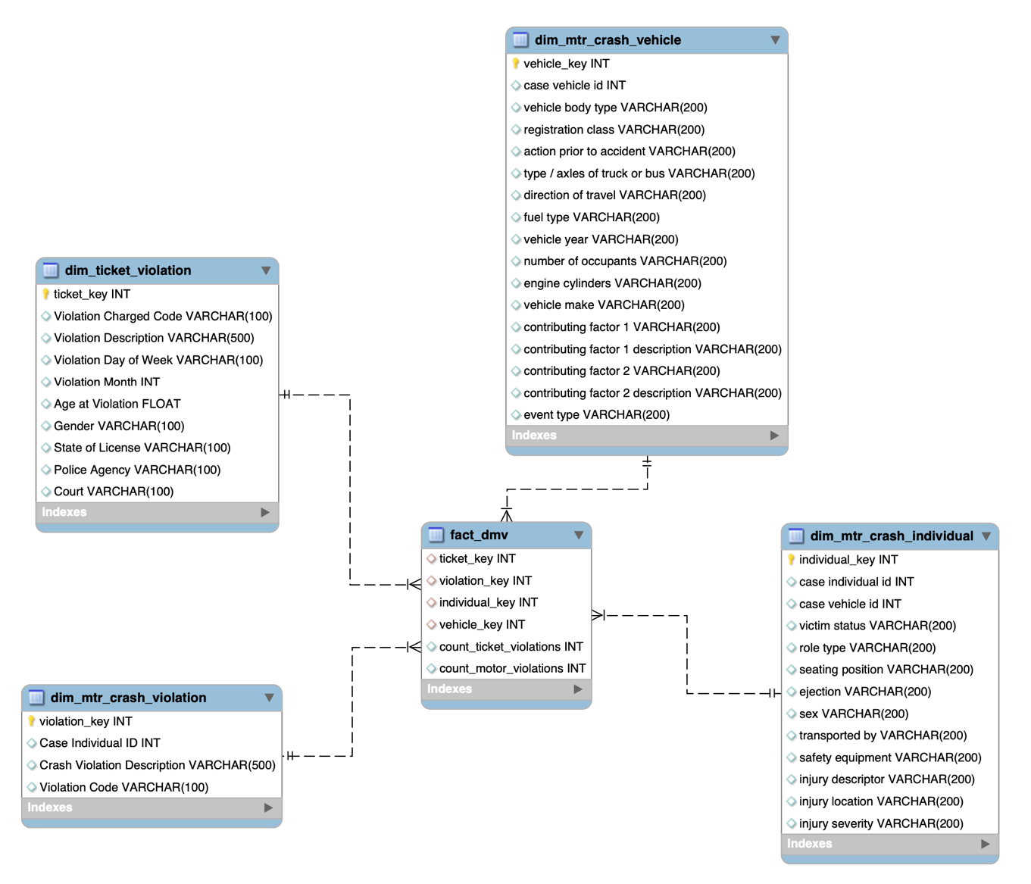

| Dimension | Attributes |
| --- | --- |
| dim_ticket_violation | ticket_key, Violation Charged Code, Violation Description, Violation Day of Week, Violation Month, Age at Violation, Gender, State of License, Police Agency, Court |
| dim_mtr_crash_vehicle | vehicle_key, case vehicle id, vehicle body type, registration class, action prior to accident, type/axles of truck or bus, direction of travel, fuel type, vehicle year, number of occupants, engine cylinders, vehicle make, contributing factor 1, contributing factor 1 description, contributing factor 2, contributing factor 2 description, event type |
| dim_mtr_crash_violation | violation_key, Case Individual ID, Crash Violation Description, Violation Code |
| dim_mtr_crash_individual | individual_key, case individual id, case vehicle id, victim status, role type, seating position, ejection, sex, transported by, safety equipment, injury descriptor, injury location, injury severity |
| fact_dmv | ticket_key, violation_key, individual_key, vehicle_key, count_ticket_violations, count_motor_violations |

Here is a brief overview of the ETL process for loading the given data into the dimensional model:

Extract the data from the source files (CSV format).

Transform the data to match the dimensional model:

Standardizing data formats and values.

Filtering out unnecessary columns and records (e.g., excluding irrelevant data or records with missing values).

Load data into dimension or fact table.